1. Smallest diameter of dot that eye can discern:

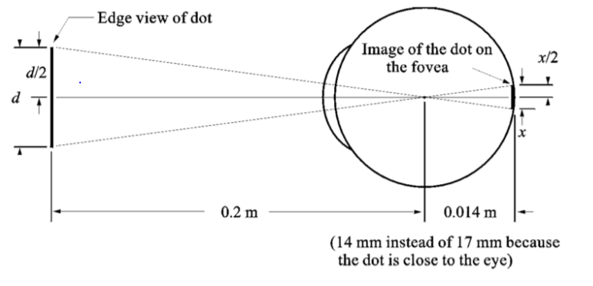

$\frac{d}{d0}=\frac{x}{di}$

do=0.2 m di=0.014 m d= $\frac{0.2}{0.014}$ x

area of fovea = 1.5 mm × 1.5 mm

cones + spaces= 336,400 it means an array of 580 ×580

we suppose that the spacing between cones is equal so in each row we have 580 cones and 579 spaces.

Scone==1.3 µm

So based on our assumptions, x should be bigger than 1.3 µm:

x=1.3 µm → d= $\frac{0.2}{0.014}$ ×1.3=18.57 µm

so, d should be bigger than 18.57 µm to be seen.



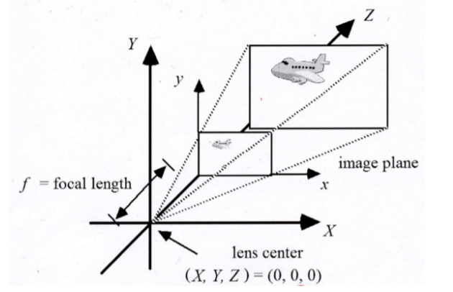

1. p= (a0, b0) = (0.4,0.5) mm

suppose C0=1 km = 1000 m f=1 cm = 0.01 m =105

(A0, B0, C0) = (a0×, b0×, C0) = (40, 50, 1000) m

1. t=0 C0=5 km =5×105

P0 = (A0, B0, C0) = (a0×, b0×, C0) = (200, 250, 5000) m

t=5 p5= (a5, b5) = (0.8,1.0) mm C0=5 km =5×105

P5= (A5, B5, C5) = (a5×, b5×, C5) = (400, 500, 5000) m

Distance between 2 points = D= P5 – P0= =

= 320.16 m

1. Velocity = v = $\frac{D}{∆t}$ = $\frac{320.16}{5}$ = 64.03 m/s

6- part h

minimum of Y= 0.0047, maximum of Y= 0.9954

minimum of I= -0.0981, maximum of I= 0.4285

minimum of Q= -0.1257, maximum of Q= 0.1383

min and max of Y, I, Q based on formulas below are often significantly different from the given image.

Y=o.299R+0.587G+0.114B

[ Min(Y) is when (R=G=B=0) =0 and Max(Y) is when (R=G=B=1.0) =1]

I=0.596R+0.274G+0.0.322B

[ Min(I) is when (R=0, G=B=1.0) = −0.606 and Max(I) is when (R=1.0, G=B=0) =0.596]

Q=o.211R+0.523G+0.312B

[ Min(Q) is when (R=B=0, G=1.0) =-0.523and Max(Q) is when (R=B=1.0, G=0) =0.523]